Integrated Intrusion Detection and Prevention System with Honeypot in Cloud Computing
Abstract
Most organizations are now migrating their services into the cloud to offer a more flexible, open, mobile and ubiquitous service. However, this also brings more exposure to security threats, cyber attacks and difficulties in reliability and safety. The proposed plan is to deploy a Honeypot in the Intrusion Detection and Prevention System (IDPS) model in order to guarantee enhanced performance, expanded level of security in the Cloud computing environment and reduction in the dangers to the Cloud environment - by focusing on the issue of how the information is stored in the Cloud. The proposed framework is viable and the model effective, in terms of utilisation of the coordinated IDPS and Honeypot by an organization. The framework described uses both Anomaly Detection (AD) and Signature Detection (SD) in collaboration, to identify different attacks and deny them access through the use of the proposed Intrusion Prevention System (IPS). The objective of this report is to highlight, recognize and entrap internal intruders by the use of the Honeypot.

INTRODUCTION
Honeypots play an important rôle in analysing the behaviour and nature of attacks being directed against computer network in the form of rogue packets and brute force techniques. The deployment of honeypots within a cloud network enhances the security monitoring mechanism. This research project deployed the honeypot in the intrusion detection and prevention system of a LAN (local area network). The aim was not only to prevent external hackers but also internal attacks. The honeypot was also used to keep a fully detailed log record of all Internet activity through it.

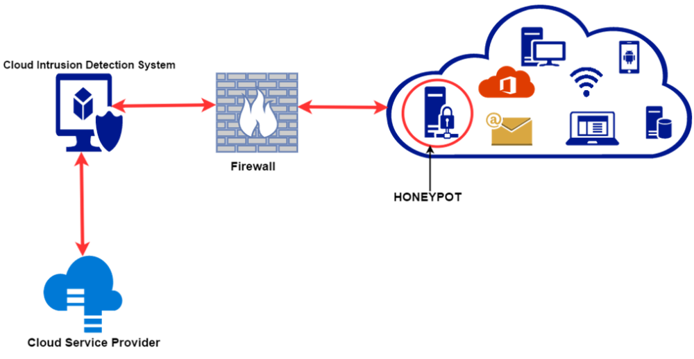
Honeypots are setup for detection, gathering information and prevention of attacks. They produce early warnings about threats and attacks. Honeypots are easy to utilise and record the required data. They are mostly utilised by corporate organizations to secure their systems from intruders. Honeypots are installed inside the firewall programs. Accordingly, they can be better controlled. A honeypot is a security asset whose worth lies in being examined, attacked, or traded off. The honeypot is a response and detection tool, instead of avoidance. Since honeypots cannot keep a specific intrusion or spread virus, it only gathers data and distinguishes the attack pattern. Subsequent to doing such, the defenders can react to this confirmation by building better resistances and countermeasures against future security threats. The honeypot execute as a scrutiny and early cautioning tool. It is a network or a system site that gives off an impression of being the detached part of the system. It is purposely made to contain the data that is extremely significant to the programmers and hacker as a means of entrapment.
The internal intruder rate is actually higher than the external attacks. Thus the only way to protect against internal intruders is to deploy a honeypot behind the firewall in the intruder detection and prevention system (IDPS) on a Cloud Computing Environment is also the proposed system of this research project. A simple IDPS may employ port scanning inside the Cloud Computing Environment.

Existing System
Existing system utilized a software defined network (SDN) and IPS managed to distinguish and block botnet/malware attacks.
Honeypot reduce false positives, while providing an extremely flexible tool that is easy to customize for different environments and threats. Internal and external threats have been addressed using Honeypots.
Disadvantages
It failed to prevent a distributed denial of service (DDoS) attack that dwelled inside or outside the cloud.
IDS is not an alternative to strong user identification and authentication mechanism.
IDS is not a solution to all security concerns.
Human intervention is required to investigate the attack once it is detected and reported.
False positives occur when IDS incorrectly identifies normal activity as being malicious.
False negatives occur when IDS fails to detect the malicious activity.

Proposed System
An Intrusion Prevention System (IPS0 in the cloud computing environment sits inline on the system and monitors when an incident happens, it initiates an action, taking into account the recommended rules. This is dissimilar to an IDS, which does not sit inline and is not active rather it is passive. Since IPSs make detection, some consider them to be superior over traditional IDSs. Thus IPSs as a cloud security tool in the overall security setup could stop intrusion attacks.

Advantages
An IDS detects and stops an attack over a system and needs to respond reactively because there is no time to install any patches nor updates.
The advantages of using a cloud based honeypot on a cloud system is similar to traditional honeypots in that it should be able to vet whether a cloud system has been compromised or attempts were made to do so.

LITERATURE SURVEY
Cloud Monitoring: definitions, issues and future directions
Aceto, Giuseppe & Botta, Alessio & Donato, Walter & Pescapè, Antonio, IEEE International Conference on Cloud Networking, CLOUDNET 2012 - Proceedings. 63-67. 10.1109/CloudNet.2012.6483656.
Despite its importance for operating Cloud systems, Cloud monitoring has received limited attention from the research community. In this position paper, we provide an analysis of Cloud monitoring. More precisely, we discuss the main motivations, basic concepts and definitions, and point out open research issues and future directions for Cloud monitoring.
Security Framework for Cloud Computing Environment: A Review
A. Malik and M. M. Nazir, J. of Emerging Trends in Computing and Information Sciences, Vol. 3, No. 3, March 2012, pp. 390 – 394. ISSN: 2079-8407.
Cloud computing has become an important platform for companies to build their infrastructures upon. If companies are thinking to take advantage of cloud based systems, they will have to seriously reassess their current security strategies as well as the cloud-specific aspects to be a successful solution provider. The focus of this study, based on existing literature, is to define a methodology for cloud providers that will protect users’ data, information which is of high importance.
Security Threats in Cloud Computing Environments
K. Lee,, Int. J. of Security and its Applications, vol. 6, no. 4, Oct. 2012, pp. 25-32. Available: http://www.sersc.org/journals/IJSIA/vol6_no4_2012/3.pdf
Cloud computing is a model for enabling service user's ubiquitous, convenient and on-demand network access to a shared pool of configurable computing resources. The security for Cloud Computing is emerging area for study and this paper provide security topic in terms of cloud computing based on analysis of Cloud Security treats and Technical Components of Cloud Computing.
Virtual Host based Intrusion Detection System for Cloud
Moorthy Manthira, M.S. & Rajeswari, M. (2013), International Journal of Engineering and Technology. 5. 5023-5029.
Cloud computing is an internet or intranet based computing, where infrastructure, information and Application are provisioned based on demand. The major breach in cloud is its security due to its huge extends of resources available in it. The major threats are data loss or leakage and hijacking. This paper presents Cloud Intrusion Detection Data Sets (CIDD) and virtual host based Intrusion Detection System. CIDD contains attack signatures based on port that are opened in cloud for communications, The signatures are prepared manually and scored using common vulnerability scoring system. Genetic Algorithm is the technique applied for generating rules from existing datasets. Large set of rules can be generated for intrusion detection by mean of genetic operation.
IDPS: An Integrated Intrusion Handling Model for Cloud.
Alsafi, Hassen & Abduallah, Wafaa & Khan Pathan, Al-Sakib. (2012).
Today, many organizations are moving their computing services towards the Cloud. This makes their computer processing available much more conveniently to users. However, it also brings new security threats and challenges about safety and reliability. In fact, Cloud Computing is an attractive and cost-saving service for buyers as it provides accessibility and reliability options for users and scalable sales for providers. In spite of being attractive, Cloud feature poses various new security threats and challenges when it comes to deploying Intrusion Detection System (IDS) in Cloud environments. Most Intrusion Detection Systems (IDSs) are designed to handle specific types of attacks. It is evident that no single technique can guarantee protection against future attacks. Hence, there is a need for an integrated scheme which can provide robust protection against a complete spectrum of threats. On the other hand, there is great need for technology that enables the network and its hosts to defend themselves with some level of intelligence in order to accurately identify and block malicious traffic and activities. In this case, it is called Intrusion prevention system (IPS). Therefore, in this paper, we emphasize on recent implementations of IDS on Cloud Computing environments in terms of security and privacy. We propose an effective and efficient model termed as the Integrated Intrusion Detection and Prevention System (IDPS) which combines both IDS and IPS in a single mechanism. Our mechanism also integrates two techniques namely, Anomaly Detection (AD) and Signature Detection (SD) that can work in cooperation to detect various numbers of attacks and stop them through the capability of IPS.
An OpenFlow-based collaborative intrusion prevention system for cloud networking
N. Huang, C. Wang, I. Liao, C. Lin and C. Kao, 2015 IEEE International Conference on Communication Software and Networks (ICCSN), Chengdu, 2015, pp. 85-92.
Software-Defined Networking (SDN) is an emerging architecture that is ideal for today's high-bandwidth, dynamic network environments. In this architecture, the control and data planes are decoupled from each other. Although much research has been performed into how SDN can resolve some of the most-glaring security issues of traditional networking, less research has addressed cloud security threats, and, in particular, botnet/malware detection and in-cloud attacks. This work proposes an intrusion prevention system for cloud networking with SDN solutions. To realize collaborative defense, mechanisms of botnet/malware blocking, scan filtering and honeypot are implemented. Malicious traffic is isolated because bot-infected VMs are removed effectively and efficiently from the private cloud. The scanning behavior can be filtered at a very early stage of prevention, making the VMs less exploitable. A honeypot mechanism is also deployed to trap attackers. Experimental results show the high detection rate, high prevention accuracy and low vulnerability of the proposed system.
ANALYSIS OF INTRUSION DETECTION SYSTEM:

An intrusion detection system (IDS) is a device or software application that monitors a network or systems for malicious activity or policy violations. Any malicious activity or violation is typically reported either to an administrator or collected centrally using a security information and event management (SIEM) system. A SIEM system combines outputs from multiple sources and uses alarm filtering techniques to distinguish malicious activity from false alarms.
IDS types range in scope from single computers to large networks. The most common classifications are network intrusion detection systems (NIDS) and host-based intrusion detection systems (HIDS). A system that monitors important operating system files is an example of an HIDS, while a system that analyzes incoming network traffic is an example of an NIDS. It is also possible to classify IDS by detection approach. The most well-known variants are signature-based detection (recognizing bad patterns, such as malware) and anomaly-based detection (detecting deviations from a model of "good" traffic, which often relies on machine learning). Another common variant is reputation-based detection (recognizing the potential threat according to the reputation scores). Some IDS products have the ability to respond to detected intrusions. Systems with response capabilities are typically referred to as an intrusion prevention system. Intrusion detection systems can also serve specific purposes by augmenting them with custom tools, such as using a honeypot to attract and characterize malicious traffic.

Comparison with Firewall
Although they both relate to network security, an IDS differs from a firewall in that a firewall looks outwardly for intrusions in order to stop them from happening. Firewalls limit access between networks to prevent intrusion and do not signal an attack from inside the network. An IDS describes a suspected intrusion once it has taken place and signals an alarm. An IDS also watches for attacks that originate from within a system. This is traditionally achieved by examining network communications, identifying heuristics and patterns (often known as signatures) of common computer attacks, and taking action to alert operators. A system that terminates connections is called an intrusion prevention system, and performs access control like an application layer firewall.

Intrusion Detection Category

Network intrusion detection systems
Network intrusion detection systems (NIDS) are placed at a strategic point or points within the network to monitor traffic to and from all devices on the network. It performs an analysis of passing traffic on the entire subnet, and matches the traffic that is passed on the subnets to the library of known attacks. Once an attack is identified, or abnormal behavior is sensed, the alert can be sent to the administrator. An example of an NIDS would be installing it on the subnet where firewalls are located in order to see if someone is trying to break into the firewall. Ideally one would scan all inbound and outbound traffic, however doing so might create a bottleneck that would impair the overall speed of the network. OPNET and NetSim are commonly used tools for simulating network intrusion detection systems. NID Systems are also capable of comparing signatures for similar packets to link and drop harmful detected packets which have a signature matching the records in the NIDS. When we classify the design of the NIDS according to the system interactivity property, there are two types: on-line and off-line NIDS, often referred to as inline and tap mode, respectively. On-line NIDS deals with the network in real time. It analyses the Ethernet packets and applies some rules, to decide if it is an attack or not. Off-line NIDS deals with stored data and passes it through some processes to decide if it is an attack or not.
NIDS can be also combined with other technologies to increase detection and prediction rates. Artificial Neural Network based IDS are capable of analyzing huge volumes of data, in a smart way, due to the self-organizing structure that allows INS IDS to more efficiently recognize intrusion patterns. Neural networks assist IDS in predicting attacks by learning from mistakes; INN IDS help develop an early warning system, based on two layers. The first layer accepts single values, while the second layer takes the first's layers output as input; the cycle repeats and allows the system to automatically recognize new unforeseen patterns in the network. This system can average 99.9% detection and classification rate, based on research results of 24 network attacks, divided in four categories: DOS, Probe, Remote-to-Local, and user-to-root.

Host intrusion detection systems
Host intrusion detection systems (HIDS) run on individual hosts or devices on the network. A HIDS monitors the inbound and outbound packets from the device only and will alert the user or administrator if suspicious activity is detected. It takes a snapshot of existing system files and matches it to the previous snapshot. If the critical system files were modified or deleted, an alert is sent to the administrator to investigate. An example of HIDS usage can be seen on mission critical machines, which are not expected to change their configurations.

HONEYPOT

In computer terminology, a honeypot is a computer security mechanism set to detect, deflect, or, in some manner, counteract attempts at unauthorized use of information systems. Generally, a honeypot consists of data (for example, in a network site) that appears to be a legitimate part of the site, but is actually isolated and monitored, and that seems to contain information or a resource of value to attackers, who are then blocked. This is similar to police sting operations, colloquially known as "baiting" a suspect.

TYPES
Honeypots can be classified based on their deployment (use/action) and based on their level of involvement. Based on deployment, honeypots may be classified as
- production honeypots
- research honeypots
Production honeypots are easy to use, capture only limited information, and are used primarily by corporations. Production honeypots are placed inside the production network with other production servers by an organization to improve their overall state of security. Normally, production honeypots are low-interaction honeypots, which are easier to deploy. They give less information about the attacks or attackers than research honeypots.
Research honeypots are run to gather information about the motives and tactics of the black hat community targeting different networks. These honeypots do not add direct value to a specific organization; instead, they are used to research the threats that organizations face and to learn how to better protect against those threats. Research honeypots are complex to deploy and maintain, capture extensive information, and are used primarily by research, military, or government organizations.

Based on design criteria, honeypots can be classified as:
- pure honeypots
- high-interaction honeypots
- low-interaction honeypots
Pure honeypots are full-fledged production systems. The activities of the attacker are monitored by using a bug tap that has been installed on the honeypot's link to the network. No other software needs to be installed. Even though a pure honeypot is useful, stealthiness of the defense mechanisms can be ensured by a more controlled mechanism.
High-interaction honeypots imitate the activities of the production systems that host a variety of services and, therefore, an attacker may be allowed a lot of services to waste their time. By employing virtual machines, multiple honeypots can be hosted on a single physical machine. Therefore, even if the honeypot is compromised, it can be restored more quickly. In general, high-interaction honeypots provide more security by being difficult to detect, but they are expensive to maintain. If virtual machines are not available, one physical computer must be maintained for each honeypot, which can be exorbitantly expensive. Example: Honeynet.
Low-interaction honeypots simulate only the services frequently requested by attackers. Since they consume relatively few resources, multiple virtual machines can easily be hosted on one physical system, the virtual systems have a short response time, and less code is required, reducing the complexity of the virtual system's security. Example: Honeyd.

Deception technology
Recently, a new market segment called deception technology has emerged using basic honeypot technology with the addition of advanced automation for scale. Deception technology addresses the automated deployment of honeypot resources over a large commercial enterprise or government institution.

Malware honeypots
Malware honeypots are used to detect malware by exploiting the known replication and attack vectors of malware. Replication vectors such as USB flash drives can easily be verified for evidence of modifications, either through manual means or utilizing special-purpose honeypots that emulate drives. Malware increasingly is used to search for and steal cryptocurrencies.

Spam versions
Spammers abuse vulnerable resources such as open mail relays and open proxies. These are servers which accept e-mail from anyone on the Internet—including spammers—and send it to its destination. Some system administrators have created honeypot programs that masquerade as these abusable resources to discover spammer activity.
There are several capabilities such honeypots provide to these administrators, and the existence of such fake abusable systems makes abuse more difficult or risky. Honeypots can be a powerful countermeasure to abuse from those who rely on very high volume abuse (e.g., spammers).
These honeypots can reveal the abuser's IP address and provide bulk spam capture (which enables operators to determine spammers' URLs and response mechanisms). As described by M. Edwards at ITPRo Today:
Typically, spammers test a mail server for open relaying by simply sending themselves an email message. If the spammer receives the email message, the mail server obviously allows open relaying. Honeypot operators, however, can use the relay test to thwart spammers. The honeypot catches the relay test email message, returns the test email message, and subsequently blocks all other email messages from that spammer. Spammers continue to use the antispam honeypot for spamming, but the spam is never delivered. Meanwhile, the honeypot operator can notify spammers' ISPs and have their Internet accounts canceled. If honeypot operators detect spammers who use open-proxy servers, they can also notify the proxy server operator to lock down the server to prevent further misuse.
The apparent source may be another abused system. Spammers and other abusers may use a chain of such abused systems to make detection of the original starting point of the abuse traffic difficult.
This in itself is indicative of the power of honeypots as anti-spam tools. In the early days of anti-spam honeypots, spammers, with little concern for hiding their location, felt safe testing for vulnerabilities and sending spam directly from their own systems. Honeypots made the abuse riskier and more difficult.
Spam still flows through open relays, but the volume is much smaller than in 2001-02. While most spam originates in the U.S., spammers hop through open relays across political boundaries to mask their origin. Honeypot operators may use intercepted relay tests to recognize and thwart attempts to relay spam through their honeypots. "Thwart" may mean "accept the relay spam but decline to deliver it." Honeypot operators may discover other details concerning the spam and the spammer by examining the captured spam messages.
Open relay honeypots include Jackpot, written in Java by Jack Cleaver; smtpot.py, written in Python by Karl A. Krueger; and spamhole (honeypot)|spamhole, written in C. The Bubblegum Proxypot is an open source honeypot (or "proxypot").

Email trap
An email address that is not used for any other purpose than to receive spam can also be considered a spam honeypot. Compared with the term "spamtrap", the term "honeypot" might be more suitable for systems and techniques that are used to detect or counterattack probes. With a spamtrap, spam arrives at its destination "legitimately"—exactly as non-spam email would arrive.
An amalgam of these techniques is Project Honey Pot, a distributed, open source project that uses honeypot pages installed on websites around the world. These honeypot pages disseminate uniquely tagged spamtrap email addresses and spammers can then be tracked—the corresponding spam mail is subsequently sent to these spamtrap e-mail addresses.

Database honeypot
Databases often get attacked by intruders using SQL injection. As such activities are not recognized by basic firewalls, companies often use database firewalls for protection. Some of the available SQL database firewalls provide/support honeypot architectures so that the intruder runs against a trap database while the web application remains functional.

DETECTION
Just as honeypots are weapons against spammers, honeypot detection systems are spammer-employed counter-weapons. As detection systems would likely use unique characteristics of specific honeypots to identify them, many honeypots in-use utilise a set of unique characteristics larger and more daunting to those seeking to detect and thereby identify them. This is an unusual circumstance in software; a situation in which "versionitis" (a large number of versions of the same software, all differing slightly from each other) can be beneficial. There's also an advantage in having some easy-to-detect honeypots deployed. Fred Cohen, the inventor of the Deception Toolkit, argues that every system running his honeypot should have a deception port which adversaries can use to detect the honeypot. Cohen believes that this might deter adversaries.

METHODOLOGY

Waterfall Methodology
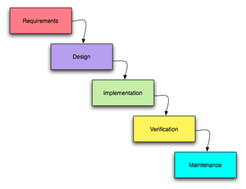

Overview:
The first concept of the Waterfall method was introduced by W.W. Royce in 1970. Royce then went on to redesign his 1st method arguing that it was flawed. In his next redesign of the Waterfall method he introduced that the initial model could be developed into an iterative model, with feedback from each phase influencing subsequent phases. His criticism of the 1st model was largely ignored and thus resulted in the current Waterfall methods of today. Most modern Systems Analysts do not like or use the Waterfall method because of its non-iterative and inflexible design process. The way the waterfall method works is that each phase must be completed perfectly for the next phase to begin. There is no overlap or moving backward in phases.
The Process steps
Requirements: they set in stone the requirements of the system.
Design: The system in question is designed and a "blueprint" is drawn for implementers (coders) to follow — this design should be a plan for implementing the requirements given.
Implementation: When the design is fully completed, an implementation of that design is made by coders. Towards the later stages of this implementation phase, system components produced by different teams are integrated.
Verification or Testing: After the implementation and integration phases are complete, the system is tested and debugged; any faults introduced in earlier phases are removed here.
Installation & Maintenance: The system components have all been integrated. The system is installed within the company and training for the system begins.
Pros:
- Time spent early on in software production can save a company hundreds of thousands of dollars. Its shown that problems found too late in the life cycle of systems development can end up costing 50 to 200 times the amount that it would have cost to fix if it were found during that particular faze.
- It places more emphasis on documentation than some other models. If someone from the team were to leave, than any new person brought aboard would be able to easily catch up because each step in the Waterfall model is designed before it is implemented, and nothing changes after the implementation of each step.

Cons:
- It is almost impossible to know exactly what is needed in each phase of the software process before some time is spent in the phase "following" it. Feedback from following phases is needed to complete satisfactory preceding phases.
- Requirements are locked in too early, even after business conditions have changed. With no user feedback many of the new user requirements will not be implemented.
- There is so much emphasis placed on design deadlines and completion that the system may not match the user needs. This could lead to extensive maintenance and much unnecessary rework that could be very expensive.

Analysis
Design
Implementation
Testing
Maintenance
Days-180
40
45
50
20
25
Gantt chart

Completed

Total Number of days to complete: 180 Days
SOFTWARE DESCRIPTION

Java:
Java was conceived by James Gosling, Patrick Naughton, Chris Wrath, Ed Frank, and Mike Sheridan at Sun Micro system. It is an platform independent programming language that extends it’s features wide over the network.Java2 version introduces an new component called “Swing” – is a set of classes that provides more power & flexible components than are possible with AWT.
- It’s a light weight package, as they are not implemented by platform-specific code.
-Related classes are contained in javax.swing and its sub packages, such as javax.swing.tree.
-Components explained in the Swing have more capabilities than those of AWT

What Is Java?
Java is two things: a programming language and a platform.
The Java Programming Language
Java is a high-level programming language that is all of the following:
- Simple
- Object-oriented
- Distributed
- Interpreted
- Robust
- Secure
- Architecture-neutral
- Portable
- High-performance
- Multithreaded
- Dynamic

Java is also unusual in that each Java program is both compiled and interpreted. With a compiler, you translate a Java program into an intermediate language called Java byte codes--the platform-independent codes interpreted by the Java interpreter. With an interpreter, each Java byte code instruction is parsed and run on the computer. Compilation happens just once; interpretation occurs each time the program is executed. This figure illustrates how this works.
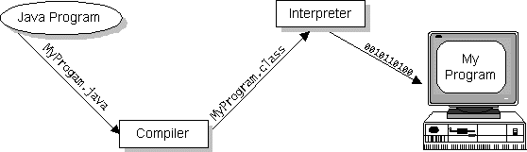

Java byte codes can be considered as the machine code instructions for the Java Virtual Machine (Java VM). Every Java interpreter, whether it's a Java development tool or a Web browser that can run Java applets, is an implementation of the Java VM. The Java VM can also be implemented in hardware.
Java byte codes help make "write once, run anywhere" possible. The Java program can be compiled into byte codes on any platform that has a Java compiler. The byte codes can then be run on any implementation of the Java VM. For example, the same Java program can run on Windows NT, Solaris, and Macintosh.

The Java Platform
A platform is the hardware or software environment in which a program runs. The Java platform differs from most other platforms in that it's a software-only platform that runs on top of other, hardware-based platforms. Most other platforms are described as a combination of hardware and operating system.
The Java platform has two components:
- The Java Virtual Machine (Java VM)
- The Java Application Programming Interface (Java API)
The Java API is a large collection of ready-made software components that provide many useful capabilities, such as graphical user interface (GUI) widgets. The Java API is grouped into libraries (packages) of related components.
The following figure depicts a Java program, such as an application or applet, that's running on the Java platform. As the figure shows, the Java API and Virtual Machine insulates the Java program from hardware dependencies.
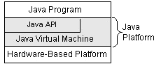
As a platform-independent environment, Java can be a bit slower than native code. However, smart compilers, well-tuned interpreters, and just-in-time byte code compilers can bring Java's performance close to that of native code without threatening portability.

What Can Java Do?
Probably the most well-known Java programs are Java applets. An applet is a Java program that adheres to certain conventions that allow it to run within a Java-enabled browser.
However, Java is not just for writing cute, entertaining applets for the World Wide Web ("Web"). Java is a general-purpose, high-level programming language and a powerful software platform. Using the generous Java API, we can write many types of programs.
The most common types of programs are probably applets and applications, where a Java application is a standalone program that runs directly on the Java platform.
How does the Java API support all of these kinds of programs?
With packages of software components that provide a wide range of functionality. The core API is the API included in every full implementation of the Java platform. The core API gives you the following features:
- The Essentials: Objects, strings, threads, numbers, input and output, data structures, system properties, date and time, and so on.
- Applets: The set of conventions used by Java applets.
- Networking: URLs, TCP and UDP sockets, and IP addresses.
- Internationalization: Help for writing programs that can be localized for users worldwide. Programs can automatically adapt to specific locales and be displayed in the appropriate language.
- Security: Both low-level and high-level, including electronic signatures, public/private key management, access control, and certificates.
- Software components: Known as JavaBeans, can plug into existing component architectures such as Microsoft's OLE/COM/Active-X architecture, OpenDoc, and Netscape's Live Connect.
- Object serialization: Allows lightweight persistence and communication via Remote Method Invocation (RMI).
- Java Database Connectivity (JDBC): Provides uniform access to a wide range of relational databases.
- Java not only has a core API, but also standard extensions. The standard extensions define APIs for 3D, servers, collaboration, telephony, speech, animation, and more.

How Will Java Change My Life?
Java is likely to make your programs better and requires less effort than other languages. We believe that Java will help you do the following:
- Get started quickly: Although Java is a powerful object-oriented language, it's easy to learn, especially for programmers already familiar with C or C++.
- Write less code: Comparisons of program metrics (class counts, method counts, and so on) suggest that a program written in Java can be four times smaller than the same program in C++.
- Write better code: The Java language encourages good coding practices, and its garbage collection helps you avoid memory leaks. Java's object orientation, its JavaBeans component architecture, and its wide-ranging, easily extendible API let you reuse other people's tested code and introduce fewer bugs.
- Develop programs faster: Your development time may be as much as twice as fast versus writing the same program in C++. Why? You write fewer lines of code with Java and Java is a simpler programming language than C++.
- Avoid platform dependencies with 100% Pure Java: You can keep your program portable by following the purity tips mentioned throughout this book and avoiding the use of libraries written in other languages.
- Write once, run anywhere: Because 100% Pure Java programs are compiled into machine-independent byte codes, they run consistently on any Java platform.
Distribute software more easily: You can upgrade applets easily from a central server. Applets take advantage of the Java feature of allowing new classes to be loaded "on the fly," without recompiling the entire program.
We explore the java.net package, which provides support for networking. Its creators have called Java “programming for the Internet.” These networking classes encapsulate the “socket” paradigm pioneered in the Berkeley Software Distribution (BSD) from the University of California at Berkeley.

Networking Basics
Ken Thompson and Dennis Ritchie developed UNIX in concert with the C language at Bell Telephone Laboratories, Murray Hill, New Jersey, in 1969. In 1978, Bill Joy was leading a project at Cal Berkeley to add many new features to UNIX, such as virtual memory and full-screen display capabilities. By early 1984, just as Bill was leaving to found Sun Microsystems, he shipped 4.2BSD, commonly known as Berkeley UNIX.4.2BSD came with a fast file system, reliable signals, interprocess communication, and, most important, networking. The networking support first found in 4.2 eventually became the de facto standard for the Internet. Berkeley’s implementation of TCP/IP remains the primary standard for communications with the Internet. The socket paradigm for inter process and network communication has also been widely adopted outside of Berkeley.

Socket Overview
A network socket is a lot like an electrical socket. Various plugs around the network have a standard way of delivering their payload. Anything that understands the standard protocol can “plug in” to the socket and communicate.
Internet protocol (IP) is a low-level routing protocol that breaks data into small packets and sends them to an address across a network, which does not guarantee to deliver said packets to the destination.
Transmission Control Protocol (TCP) is a higher-level protocol that manages to reliably transmit data. A third protocol, User Datagram Protocol (UDP), sits next to TCP and can be used directly to support fast, connectionless, unreliable transport of packets.
Client/Server
A server is anything that has some resource that can be shared. There are compute servers, which provide computing power; print servers, which manage a collection of printers; disk servers, which provide networked disk space; and web servers, which store web pages. A client is simply any other entity that wants to gain access to a particular server.
In Berkeley sockets, the notion of a socket allows as single computer to serve many different clients at once, as well as serving many different types of information. This feat is managed by the introduction of a port, which is a numbered socket on a particular machine. A server process is said to “listen” to a port until a client connects to it. A server is allowed to accept multiple clients connected to the same port number, although each session is unique. To mange multiple client connections, a server process must be multithreaded or have some other means of multiplexing the simultaneous I/O.

Reserved Sockets
Once connected, a higher-level protocol ensues, which is dependent on which port you are using. TCP/IP reserves the lower, 1,024 ports for specific protocols. Port number 21 is for FTP, 23 is for Telnet, 25 is for e-mail, 79 is for finger, 80 is for HTTP, 119 is for Netnews-and the list goes on. It is up to each protocol to determine how a client should interact with the port.

Java and the Net
Java supports TCP/IP both by extending the already established stream I/O interface. Java supports both the TCP and UDP protocol families. TCP is used for reliable stream-based I/O across the network. UDP supports a simpler, hence faster, point-to-point datagram-oriented model.
InetAddress
The InetAddress class is used to encapsulate both the numerical IP address and the domain name for that address. We interact with this class by using the name of an IP host, which is more convenient and understandable than its IP address. The InetAddress class hides the number inside. As of Java 2, version 1.4, InetAddress can handle both IPv4 and IPv6 addresses.

Factory Methods
The InetAddress class has no visible constructors. To create an InetAddress object, we use one of the available factory methods. Factory methods are merely a convention whereby static methods in a class return an instance of that class. This is done in lieu of overloading a constructor with various parameter lists when having unique method names makes the results much clearer.
Three commonly used InetAddress factory methods are shown here.
static InetAddress getLocalHost( ) throws UnknownHostException
static InetAddress getByName(String hostName) throws UnknowsHostException
static InetAddress[ ] getAllByName(String hostName)
throws UnknownHostException

The getLocalHost( ) method simply returns the InetAddress object that represents the local host. The getByName( ) method returns an InetAddress for a host name passed to it. If these methods are unable to resolve the host name, they throw an UnknownHostException.
On the internet, it is common for a single name to be used to represent several machines. In the world of web servers, this is one way to provide some degree of scaling. The getAllByName ( ) factory method returns an array of InetAddresses that represent all of the addresses that a particular name resolves to. It will also throw an UnknownHostException if it can’t resolve the name to at least one address. Java 2, version 1.4 also includes the factory method getByAddress( ), which takes an IP address and returns an InetAddress object. Either an IPv4 or an IPv6 address can be used.

Instance Methods
The InetAddress class also has several other methods, which can be used on the objects returned by the methods just discussed. Here are some of the most commonly used.
Boolean equals (Object other)- Returns true if this object has the same Internet address as other.
byte[ ] getAddress( )- Returns a byte array that represents the object’s Internet address in network byte order.
String getHostAddress( )- Returns a string that represents the host address associated with the InetAddress object.
String getHostName( )- Returns a string that represents the host name associated with the InetAddress object.
boolean isMulticastAddress( )- Returns true if this Internet address is a multicast address. Otherwise, it returns false.
String toString( )- Returns a string that lists the host name and the IP address for conveneince.
Internet addresses are looked up in a series of hierarchically cached servers. That means that your local computer might know a particular name-to-IP-address mapping autocratically, such as for itself and nearby servers. For other names, it may ask a local DNS server for IP address information. If that server doesn’t have a particular address, it can go to a remote site and ask for it. This can continue all the way up to the root server, called InterNIC (internic.net).

TCP/IP Client Sockets
TCP/IP sockets are used to implement reliable, bidirectional, persistent, point-to-point, stream-based connections between hosts on the Internet. A socket can be used to connect Java’s I/O system to other programs that may reside either on the local machine or on any other machine on the Internet.
There are two kinds of TCP sockets in Java. One is for servers, and the other is for clients. The ServerSocket class is designed to be a “listener,” which waits for clients to connect before doing anything. The Socket class is designed to connect to server sockets and initiate protocol exchanges.
The creation of a Socket object implicitly establishes a connection between the client and server. There are no methods or constructors that explicitly expose the details of establishing that connection. Here are two constructors used to create client sockets:
Socket(String hostName, int port) Creates a socket connecting the local host to the named host and port; can throw an UnknownHostException or anIOException.
Socket(InetAddress ipAddress, int port) Creates a socket using a preexisting InetAddress object and a port; can throw an IOException.
A socket can be examined at any time for the address and port information associated with it, by use of the following methods:
InetAddress getInetAddress( )- Returns the InetAddress associated with the Socket object.
int getPort( ) Returns the remote port to which this Socket object is connected.
int getLocalPort( ) Returns the local port to which this Socket object is connected.
Once the Socket object has been created, it can also be examined to gain access to the input and output streams associated with it. Each of these methods can throw an IOException if the sockets have been invalidated by a loss of connection on the Net.
InputStream getInputStream( )Returns the InputStream associated with the invoking socket.
OutputStream getOutputStream( ) Returns the OutputStream associated with the invoking socket.

TCP/IP Server Sockets
Java has a different socket class that must be used for creating server applications. The ServerSocket class is used to create servers that listen for either local or remote client programs to connect to them on published ports. ServerSockets are quite different form normal Sockets.
When we create a ServerSocket, it will register itself with the system as having an interest in client connections. The constructors for ServerSocket reflect the port number that we wish to accept connection on and, optionally, how long we want the queue for said port to be. The queue length tells the system how many client connection it can leave pending before it should simply refuse connections. The default is 50. The constructors might throw an IOException under adverse conditions. Here are the constructors:
ServerSocket(int port) Creates server socket on the specified port with a queue length of 50.
Serversocket(int port, int maxQueue)-Creates a server socket on the specified port with a maximum queue length of maxQueue.
ServerSocket(int port, int maxQueue, InetAddress localAddress)-Creates a server socket on the specified port with a maximum queue length of maxQueue. On a multihomed host, localAddress specifies the IP address to which this socket binds.
ServerSocket has a method called accept( ), which is a blocking call that will wait for a client to initiate communications, and then return with a normal Socket that is then used for communication with the client.

JAVA SWING

Swing is a widget toolkit for Java. It is part of Sun Microsystems' Java Foundation Classes (JFC) — an API for providing a graphical user interface (GUI) for Java programs.
Swing was developed to provide a more sophisticated set of GUI components than the earlier Abstract Window Toolkit. Swing provides a native look and feel that emulates the look and feel of several platforms, and also supports a pluggable look and feel that allows applications to have a look and feel unrelated to the underlying platform.

Swing overview

The Internet Foundation Classes (IFC) were a graphics library for Java originally developed by Netscape Communications Corporation and first released on December 16, 1996. On April 2, 1997, Sun Microsystems and Netscape Communications Corporation announced their intention to incorporate IFC with other technologies to form the Java Foundation Classes.
Swing introduced a mechanism that allowed the look and feel of every component in an application to be altered without making substantial changes to the application code. The introduction of support for a pluggable look and feel allows Swing components to emulate the appearance of native components while still retaining the benefits of platform independence. This feature also makes it easy to make an application written in Swing look very different from native programs if desired.
Originally distributed as a separately downloadable library, Swing has been included as part of the Java Standard Edition since release 1.2. The Swing classes and components are contained in the javax.swing package hierarchy.

Main New Features
- Lightweight. Not built on native window-system windows.
- Much bigger set of built-in controls. Trees, image buttons, tabbed panes, sliders, toolbars, color choosers, tables, text areas to display HTML or RTF, etc.
- Much more customizable. Can change border, text alignment, or add image to almost any control. Can customize how minor features are drawn. Can separate internal representation from visual appearance.
- "Pluggable" look and feel. Can change look and feel at runtime, or design own look and feel.
- Many miscellaneous new features. Double-buffering built in, tool tips, dockable tool bars, keyboard accelerators, custom cursors, etc.

Difference between swing and AWT
- Swings are faster than awt.
- Awt uses heavyweight components for user interfaces.
- Swing uses lightweight components
- Implementations of AWT components use native code which may vary from one machine to another.
- Swing components are pure java code

Architecture
Swing is a platform-independent, Model-View-Controller GUI framework for Java. It follows a single-threaded programming model, and possesses the following traits:

Foundations

Platform independence
Swing is platform independent both in terms of its expression (Java) and its implementation (non-native universal rendering of widgets).

Extensibility
Swing is a highly partitioned architecture, which allows for the "plugging" of various custom implementations of specified framework interfaces: Users can provide their own custom implementation(s) of these components to override the default implementations. In general, Swing users can extend the framework by extending existing (framework) classes and/or providing alternative implementations of core components.

Component-oriented
Swing is a component-based framework. The distinction between objects and components is a fairly subtle point: concisely, a component is a well-behaved object with a known/specified characteristic pattern of behaviour. Swing objects asynchronously fire events, have "bound" properties, and respond to a well-known set of commands (specific to the component.) Specifically, Swing components are Java Beans components, compliant with the Java Beans Component Architecture specifications.

Customizable
Given the programmatic rendering model of the Swing framework, fine control over the details of rendering of a component is possible in Swing. As a general pattern, the visual representation of a Swing component is a composition of a standard set of elements, such as a "border", "inset", decorations, etc. Typically, users will programmatically customize a standard Swing component (such as a JTable) by assigning specific Borders, Colors, Backgrounds, opacities, etc., as the properties of that component. The core component will then use these property (settings) to determine the appropriate renderers to use in painting its various aspects. However, it is also completely possible to create unique GUI controls with highly customized visual representation.

Configurable
Swing's heavy reliance on runtime mechanisms and indirect composition patterns allows it to respond at runtime to fundamental changes in its settings. For example, a Swing-based application can change its look and feel at runtime. Further, users can provide their own look and feel implementation, which allows for uniform changes in the look and feel of existing Swing applications without any programmatic change to the application code.
Lightweight UI
Swing's configurability is a result of a choice not to use the native host OS's GUI controls for displaying itself. Swing "paints" its controls programmatically through the use of Java 2D APIs, rather than calling into a native user interface toolkit. Thus, a Swing component does not have a corresponding native OS GUI component, and is free to render itself in any way that is possible with the underlying graphics APIs.
However, at its core every Swing component relies on an AWT container, since (Swing's) JComponent extends (AWT's) Container. This allows Swing to plug into the host OS's GUI management framework, including the crucial device/screen mappings and user interactions, such as key presses or mouse movements. Swing simply "transposes" its own (OS agnostic) semantics over the underlying (OS specific) components. So, for example, every Swing component paints its rendition on the graphic device in response to a call to component.paint(), which is defined in (AWT) Container. But unlike AWT components, which delegated the painting to their OS-native "heavyweight" widget, Swing components are responsible for their own rendering.
This transposition and decoupling is not merely visual, and extends to Swing's management and application of its own OS-independent semantics for events fired within its component containment hierarchies. Generally speaking, the Swing Architecture delegates the task of mapping the various flavors of OS GUI semantics onto a simple, but generalized, pattern to the AWT container. Building on that generalized platform, it establishes its own rich and complex GUI semantics in the form of the JComponent model. A review of the source of Container java and JComponent java classes is recommended for further insights into the nature of the interface between Swing's lightweight components and AWT's heavyweight widgets.

Loosely-Coupled/MVC
The Swing library makes heavy use of the Model/View/Controller software design pattern, which conceptually decouples the data being viewed from the user interface controls through which it is viewed. Because of this, most Swing components have associated models (which are specified in terms of Java interfaces), and the programmer can use various default implementations or provide their own. The framework provides default implementations of model interfaces for all of its concrete components.^{[1]}
Typically, Swing component model objects are responsible for providing a concise interface defining events fired, and accessible properties for the (conceptual) data model for use by the associated JComponent. Given that the overall MVC pattern is a loosely-coupled collaborative object relationship pattern, the model provides the programmatic means for attaching event listeners to the data model object. Typically, these events are model centric (ex: a "row inserted" event in a table model) and are mapped by the JComponent specialization into a meaningful event for the GUI component.
For example, the JTable has a model called TableModel that describes an interface for how a table would access tabular data. A default implementation of this operates on a two-dimensional array.
The view component of a Swing JComponent is the object used to graphically "represent" the conceptual GUI control. A distinction of Swing, as a GUI framework, is in its reliance on programmatically-rendered GUI controls (as opposed to the use of the native host OS's GUI controls). Prior to Java 6 Update 10, this distinction was a source of complications when mixing AWT controls, which use native controls, with Swing controls in a GUI (see Mixing AWT and Swing components).
Finally, in terms of visual composition and management, Swing favors relative layouts (which specify the positional relationships between components) as opposed to absolute layouts (which specify the exact location and size of components). This bias towards "fluid"' visual ordering is due to its origins in the applet operating environment that framed the design and development of the original Java GUI toolkit. (Conceptually, this view of the layout management is quite similar to that which informs the rendering of HTML content in browsers, and addresses the same set of concerns that motivated the former.)

Look and feel
Swing allows one to specialize the look and feel of widgets, by modifying the default (via runtime parameters), deriving from an existing one, by creating one from scratch, or, beginning with J2SE 5.0, by using the skinnable synth Look and Feel (see Synth Look and Feel), which is configured with an XML property file. The look and feel can be changed at runtime, and early demonstrations of Swing frequently provided a way to do this.

Relationship to AWT

AWT and Swing class hierarchy
Since early versions of Java, a portion of the Abstract Window Toolkit (AWT) has provided platform-independent APIs for user interface components. In AWT, each component is rendered and controlled by a native peer component specific to the underlying windowing system.
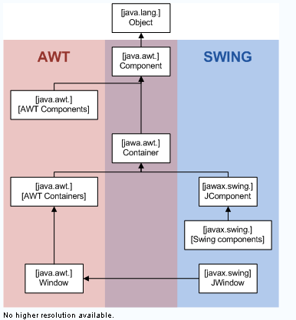
By contrast, Swing components are often described as lightweight because they do not require allocation of native resources in the operating system's windowing toolkit. The AWT components are referred to as heavyweight components.
Much of the Swing API is generally a complementary extension of the AWT rather than a direct replacement. In fact, every Swing lightweight interface ultimately exists within an AWT heavyweight component because all of the top-level components in Swing (JApplet, JDialog, JFrame, and JWindow) extend an AWT top-level container. However, the use of both lightweight and heavyweight components within the same window is generally discouraged due to Z-order incompatibilities.
The core rendering functionality used by Swing to draw its lightweight components is provided by Java 2D, another part of JFC.

Relationship to SWT
The Standard Widget Toolkit (SWT) is a competing toolkit originally developed by IBM and now maintained by the Eclipse community. SWT's implementation has more in common with the heavyweight components of AWT. This confers benefits such as more accurate fidelity with the underlying native windowing toolkit, at the cost of an increased exposure to the native platform in the programming model.
The advent of SWT has given rise to a great deal of division among Java desktop developers, with many strongly favoring either SWT or Swing. Sun's development on Swing continues to focus on platform look and feel (PLAF) fidelity with each platform's windowing toolkit in the approaching Java SE 7 release (as of December 2006).
There has been significant debate and speculation about the performance of SWT versus Swing; some hinted that SWT's heavy dependence on JNI would make it slower when the GUI component and Java need to communicate data, but faster at rendering when the data model has been loaded into the GUI. A fairly thorough benchmarks show Swing performing better on head to head direct comparisons..
SWT serves the Windows platform very well but is considered by some to be less effective as a technology for cross-platform development. By using the high-level features of each native windowing toolkit, SWT returns to the issues seen in the mid 90's (with toolkits like zApp, Zinc, XVT and IBM/Smalltalk) where toolkits attempted to mask differences in focus behaviour, event triggering and graphical layout. Failure to match behavior on each platform can cause subtle but difficult-to-resolve bugs that impact user interaction and the appearance of the GUI.

ARCHITECTURE

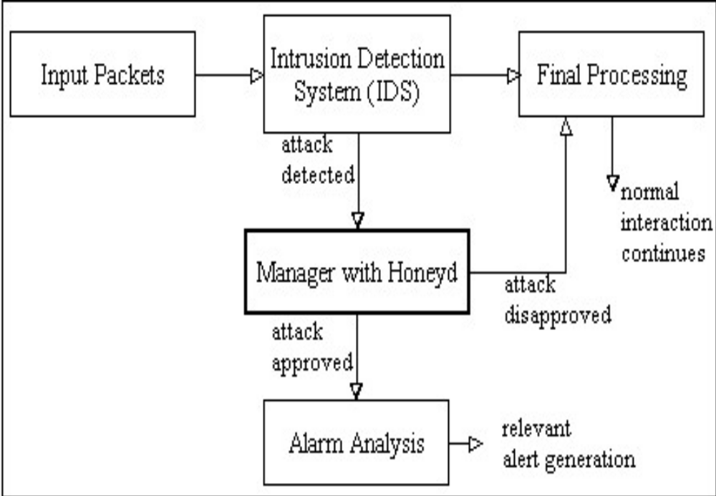

IIDSALGORITHM

STEP 1: Read incoming data from users
STEP 2: IF Data size is in limit:
Forward data to Server
ELSE
Consider as suspicious activity
STEP 3: Repeat step 2 untill suspicious data received 3 times
STEP 4: Update suspicious user details in honeypot

HONEYPOT ALGORITHM
STEP 1: Read suspicious user details
STEP 2: Send validation code to user
STEP 3: Read Validation code and other data from user
STEP 4: IF details matched
Consider user as genuine.
ELSE
Consider user as attacker and block him
Data Flow Diagram
Level 0
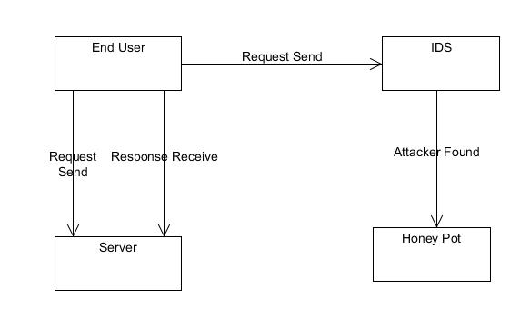
Level 1
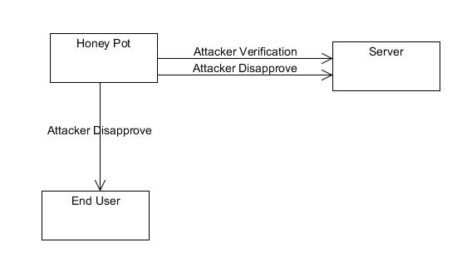
Level 2
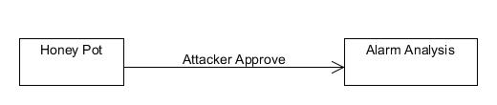
UML DIAGRAM
Use case diagram
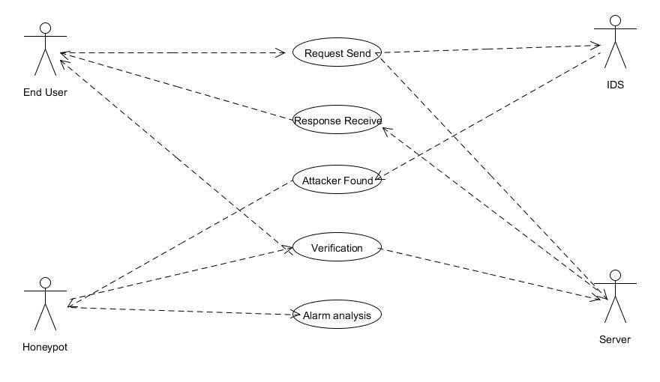

SEQUENCE DIAGRAM
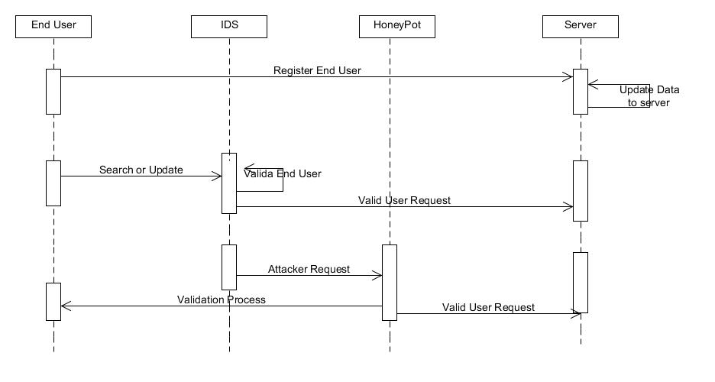
ACTIVITY DIAGRAM
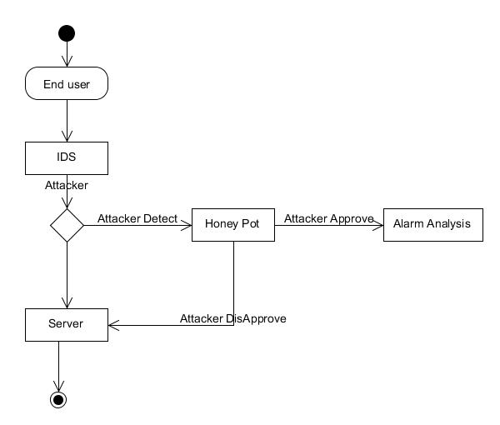
Collaboration diagram
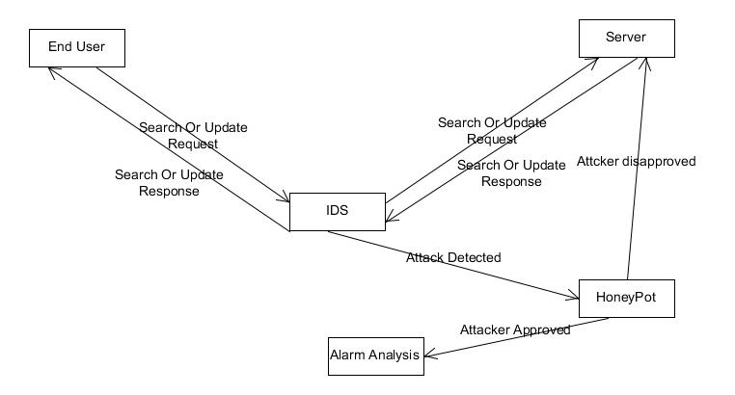
Class diagram

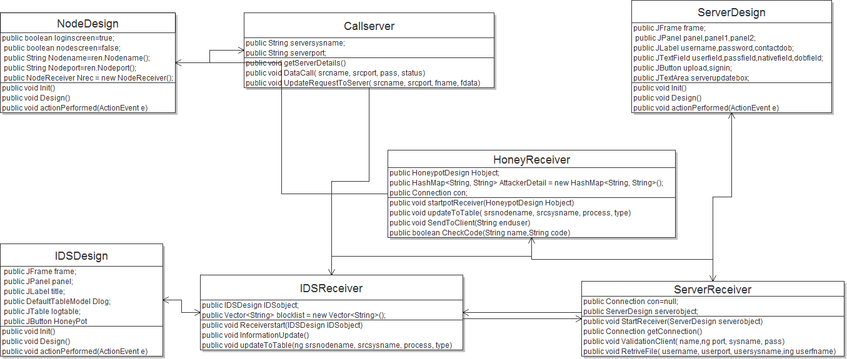

IMPLEMENTATION

This project is implementation consists of below mentioned modules:

Client
Client is a user who communicates to the server through IDS system. User can login his userid and password provided by server and do transations like file upload and download.

Intrusion Detection System
Intrusion detection technology in general helps to find out the illegal intrusions from inside and outside of the local network by tracking the intruders’ trail, such as the records of failure access trails. A typical IDS consists of the following parts: event generator, event analyzer, response units and event databases. The data are exchanged in form of GIDOs (Generalized Intrusion Detection Objects) between the parts. GIDO is the specification of messaging as its encoded content is either some particular occurrence happened at some particular time, or some conclusion about a set of events or an intrusion to carry out an action. Each part might be implemented as a single process on a computer, or might be a collection of many processes on a number of computers. The event generator obtains events from data outside the intrusion detection system, generates events based on the traffic thereon and handovers them in GIDO format to the other parts.

server
Server holds the data provided by client. Server generates username and password for new user and sends it through email to client.

Honeypot
Using the honeypot scheme, this system is able to avoid many wrong decisions made by IDS. In this system alarming adversaries, initially detected by the IDS, will be rerouted to a honeypot network for a more close investigation. If as a result of this investigation, it is found that the alarm decision made by the IDS of the agent is wrong, the connection will be guided to the original destination in order to continue the previous interaction. This action is hidden to the user.

Client Validation
When a client is blocked by IDS due to its suspicious behavior, honeypot generates a verification code for client and sends it by email. The client has to authenticate itself using the verification code and continue with the services provided by server.

SYSTEM TESTING

The purpose of testing is to discover errors. Testing is the process of trying to discover every conceivable fault or weakness in a work product. It provides a way to check the functionality of components, sub assemblies, assemblies and/or a finished product It is the process of exercising software with the intent of ensuring that the Software system meets its requirements and user expectations and does not fail in an unacceptable manner. There are various types of test. Each test type addresses a specific testing requirement.

Types of Tests

Unit testing
Unit testing involves the design of test cases that validate that the internal program logic is functioning properly, and that program input produces valid outputs. All decision branches and internal code flow should be validated. It is the testing of individual software units of the application .it is done after the completion of an individual unit before integration. This is a structural testing, that relies on knowledge of its construction and is invasive. Unit tests perform basic tests at component level and test a specific business process, application, and/or system configuration. Unit tests ensure that each unique path of a business process performs accurately to the documented specifications and contains clearly defined inputs and expected results.

Functional test
Functional tests provide systematic demonstrations that functions tested are available as specified by the business and technical requirements, system documentation, and user manuals.
Functional testing is centered on the following items:
Valid Input : identified classes of valid input must be accepted.
Invalid Input : identified classes of invalid input must be rejected.
Functions : identified functions must be exercised.
Output : identified classes of application outputs must be exercised.
Systems/Procedures: interfacing systems or procedures must be invoked.

System Test
System testing ensures that the entire integrated software system meets requirements. It tests a configuration to ensure known and predictable results. An example of system testing is the configuration oriented system integration test. System testing is based on process descriptions and flows, emphasizing pre-driven process links and integration points.
Performance Test
The Performance test ensures that the output be produced within the time limits,and the time taken by the system for compiling, giving response to the users and request being send to the system for to retrieve the results.

Integration Testing
Software integration testing is the incremental integration testing of two or more integrated software components on a single platform to produce failures caused by interface defects.
The task of the integration test is to check that components or software applications, e.g. components in a software system or – one step up – software applications at the company level – interact without error.
Integration testing for Server Synchronization:
- Testing the IP Address for to communicate with server.
- Check the download request is sent from client to IDS
- Check the file is downloaded in client.
- Check the attacker is blocked by IDS
- Check the user is verified by honeypot

Acceptance Testing
User Acceptance Testing is a critical phase of any project and requires significant participation by the end user. It also ensures that the system meets the functional requirements.
Testing results are as mentioned in the table below:
MODULE | GIVEN INPUT | EXPECTED OUTPUT | ACTUAL OUTPUT | RESULT
Client | Login request | Request to be sent to server through IDS | Request successfully sent to server through IDS | OK
client | search request from client | Request to be sent to server through IDS | Request successfully sent to server through IDS | OK
Client | Update request from client | Request to be sent to IDS | Request successfully sent to IDS | OK
IDS | Update request from client | File size to be verified and sent to server.  If file exceeds 500 bytes, request should be blocked. | Request successfully verified. Blocked user details sent to honeypot | OK
Honeypot | Attacker details from IDS | Attacker details to be updated in attacker list | Attacker details successfully added in attacker list | OK
Honeypot | Validation data from client with verification code | Client to be validated | Client successfully validated | OK
server | Client requests | Client requests to be processed | Client requests successfully processed | OK

SNAPSHOT

